IMTSquare Company

AnyChange Software

Use Cases and Use Case Model

v1.0

Revision History

|  |  |  |  |  |  |
| --- | --- | --- | --- | --- | --- |
| **Date** | **Version** | **Type** | **Description** | **Prepared by** | **Checked by** |
| 29/03/2023 | 1.0 | IFC | Preliminary draft | IMT2 Dev | IMT2 QA/QC |
|  |  |  |  |  |  |
|  |  |  |  |  |  |
|  |  |  |  |  |  |

AnyChange

Use Cases and Use Case Model

# Use Case Model

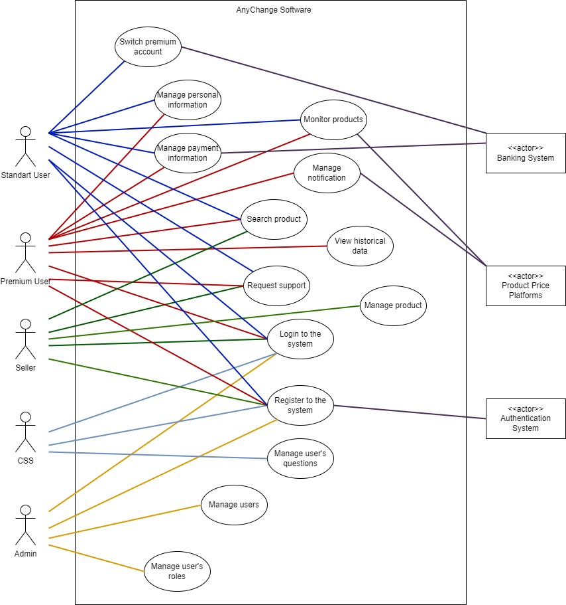

## Use Case UC1: Register to System

User wants to register to system. System displays registration form. User enters user name and password. User clicks on register. System completes registration.

**Scope:** AnyChange Software

**Level:** User Goal

**Primary Actor**: Standart User, Premium User, Administrator, Seller, Customer Service Staff (CSS)

**Preconditions**: Registration page is loaded.

1. New user clicks on new 'create new Account link'.
2. New user is at Registration screen.
3. New user enters the following details in the Registration Screen.
4. User Name
5. Password
6. User clicks on save and the system validates all the user information and displays the signing information page.
7. User enters the new Username and Password.
8. System validates that the Username is already in use. If not, system displays the

new account confirmation page.

**Success Guarantee (Post Conditions)**:

‘Account Verification Screen’ lets the user review his/her account details and then successfully register as a user of this site.

## Use Case UC2: Log in to System

User wants to login to the system. System displays login page. User enters e-mail and clicks on log in. System allows user to login.

**Scope:** AnyChange Software

**Level:** User Goal

**Primary Actor**: Standart User, Premium User, Administrator, Seller, Customer Service Staff

**Preconditions**: The user must be registered in the system.

1. The user browses to the "Sign In" page.
2. The user enters his/her username and password in the returning user section of the "Sign In" screen.
3. The system validates the username and password (successfully) and displays the user's account information page.

**2a.** User forgot his/her username or password or both.

* 1. User clicks the "Forgot Username/Password?" button.
  2. System display e mail verification page.
  3. User enter registered email adress.
  4. System sends e-mail to user’s mail which includes password reset link.
  5. User click this link.
  6. System resets the users account.
  7. The user utilizes the new username/password information to log in following the basic flow.

**3a.** System determines that the username or password is invalid.

**1.** System informs the user to try again and shows error messages.

**2.** User enters his/her correct username and password.

**3.** The system validates the username and password (successfully) and displays the user's account information page.

## Use Case UC3: Manage Personal Information

**Scope:** AnyChange Software

**Level:** User Goal

**Primary Actor:** Standart User, Premium User

**Preconditions:** User successfully logged in to the system.

**Main Success Scenario:**

1. User wants to manage user information.
2. System displays profile information (phone number, name, e-mail, address fields).
3. User configures information and clicks on save.
4. System saves the updates.

**Extensions:**

**\*a.** At any time, system fails:

1. System displays an error message and cancels the update request.
2. User restarts the system.

**3a.** There is a mistaken field in the data entered by the user.

1. System displays an error message.
2. User selects try again.
3. Go to step 3 of the main success scenario.

**Success Guarantees:**

User’s profile information update is successfully saved by the system.

## Use Case UC4: Manage Payment Information

**Scope:** AnyChange Software

**Level:** User Goal

**Primary Actor:** Standart User, Premium User

**Preconditions:** User successfully logged in to the system.

**Main Success Scenario:**

1. User wants to manage payment information.
2. System displays payment information page.
3. User adds credit card information.
4. System saves the updates.

User repeats steps 3-4 until indicates done.

**Extensions:**

**\*a.** At any time, system fails:

1. System displays an error message and cancels the update request.
2. User restarts the system.

**3a.** There are missing digits in card information.

1. System displays an error message.
2. User selects confirm to try again.
3. System re-opens payment information page.

**3b.** User wants to remove card.

1. System displays payment information page.
2. User selects card(s) to remove and clicks on delete.
3. Go to step 4 of the main success scenario.

**Success Guarantees:**

Payment information is successfully saved.

## Use Case UC5: Switch Premium Account

**Scope:** AnyChange Software

**Level:** User Goal

**Primary Actor:** Standart User

**Preconditions:** User successfully logged in to the system.

**Main Success Scenario:**

1. User wants to switch to premium account.
2. System displays options for membership.
3. User selects an option.
4. System waits for confirmation from user to continue the process.
5. User gives confirmation
6. System checks payment information of the user and updates the account information of the user.

**Extensions:**

**\*a.** At any time, system fails:

1. System displays an error message and cancels the update request.
2. User restarts the system.

**3a.** User wants to select a different option

1. System displays the options.
2. User selects new option.
3. System updates the selection.

**4a.** User does not give confirmation

1. System cancels the process and goes to step 2 of the main success scenario.

**6a.** System doesn’t check the payment information

1. System cancels the process and gives error message about the payment information

**Success Guarantees:**

Account information is successfully updated.

## Use Case UC6: Monitor Products

**Scope:** AnyChange Software

**Level:** User Goal

**Primary Actor:** Standart User, Premium User

**Preconditions:** User successfully logged in to the system.

**Main Success Scenario:**

1. User wants to monitor products.
2. System presents the product list alphabetically and shows some brief information about product
3. User selects product(s) to monitor actual price of the product for each seller and each price platform.

User repeats step 3 until indicates done.

1. System displays price and other information for selected products.

**Extensions:**

**\*a.** At any time, system fails:

1. System displays an error message.
2. User restarts the system.

**3a.** User wants to remove products.

1. System displays the selected products.
2. User selects products to remove and clicks on remove.
3. System updates the page.

**3b.** User wants to update number of products.

1. System displays the selected products.
2. User selects new products.
3. System updates the page.

**Success Guarantees:**

Monitoring page is updated. All selected products and necessary information about the products are displayed to User.

## Use Case UC7: Manage Notification

**Scope:** AnyChange Software

**Level:** User Goal

**Primary Actor:** PremiumUser

**Preconditions:** User successfully logged in to the system and premium account is checked.

**Main Success Scenario:**

1. User wants to create a new notification instruction.
2. System displays the products.
3. User selects a product.
4. System displays instruction settings *(like period, price limit or available in stock)*.
5. User enters all necessary instruction settings.
6. System saves the new notification instruction.

**Extensions:**

**\*a.** At any time, system fails:

1. System displays an error message and cancels the request.
2. User restarts the system.

**3a.** User wants to select a different product

1. System displays the products.
2. User selects new product.
3. System updates the product and main scenario goes from step 4.

**Success Guarantees:**

Notification instruction is saved and can be sent successfully.

## Use Case UC8: Search Product

**Scope:** AnyChange Software

**Level:** User Goal

**Primary Actor:** Standart User,PremiumUser, Seller

**Preconditions:** User successfully logged in to the system.

**Main Success Scenario:**

1. User enters the products page.
2. System displays the products.
3. User wants to search product according to specific filter options.
4. System shows filtering options.
5. User selects one or more filtering options
6. System filters products according to the user’s selection and shows results

**Extensions:**

**\*a.** At any time, system fails:

1. System displays an error message and cancels the request.
2. User restarts the system.

**Success Guarantees:**

System shows the result successfully according to the user’s filtering selection

## Use Case UC9: Manage Product

**Scope:** AnyChange Software

**Level:** User Goal

**Primary Actor:** Seller

**Preconditions:** Seller successfully logged in to the system.

**Main Success Scenario:**

**1.** Seller wants to manage products.

**2.** System prompts the seller to select one of the following two options:

* Add new product
  + Modify existing product, i.e., update or remove product.

**2A**. If the seller selects the “***Add new product***” option,

2a. The system prompts the user to enter the product details like name, quantity, price, image and other specifications.

2b. The seller enters the necessary information and clicks “Save”.

2c. System saves the product and updates the product list of the seller

**2B.** If the seller selects the “***Modify Existing Product***” option,

2a. The system displays the products of the seller

2b. The seller select a product.

2c. The user either removes the item from the catalog by clicking “Remove Product” or modifies the specifications about the product and clicks “Update”.

2d. The system updates the product’s information

**Extensions:**

**2A. 2b 1 Incomplete Item Information**

If the user fails to enter any of the mandatory item information like Item Name, Quantity and Price then the system displays an appropriate error message to the user.

**2B. 2c 1 Incomplete Item Information**

If the user fails to enter any of the mandatory item information like Item Name, Quantity and Price then the system displays an appropriate error message to the user.

**Success Guarantees:**

Products on the system are displayed as arranged by the seller.

## Use Case UC10: Request Support

**Scope:** AnyChange Software

**Level:** User Goal

**Primary Actor:** Standart User,PremiumUser, Seller

**Preconditions:** User successfully logged in to the system.

**Main Success Scenario:**

1. User wants to request customer support about the system.
2. System opens dialogue box.
3. User enters questions to the dialogue box.
4. System saves the message.

**Extensions:**

**\*a.** At any time, system fails:

1. System displays an error message and cancels the request.
2. User restarts the system.

**Success Guarantees:**

Questions are saved successfully.

## Use Case UC11: View Historical Data

**Level:** User Goal

**Primary Actor:** PremiumUser

**Preconditions:** PremiumUser successfully logged in to the system.

**Main Success Scenario:**

1. User enters the products page.
2. System displays the products.
3. User selects a product and clicks “Show Historical Data”.
4. System opens a modal and waits for the time period input.
5. User enters time period.
6. System filters historical price data for given time period and displays to the user.

**Extensions:**

**\*a.** At any time, system fails:

1. System displays an error message and cancels the request.
2. User restarts the system.

**Success Guarantees:**

System shows the result successfully according to the time period.

## Use Case UC12: Manage User Questions

**Level:** User Goal

**Primary Actor:** Customer service staff

**Preconditions:** CSS user successfully logged in to the system.

**Main Success Scenario:**

1. CSS user wants to manage user questions.
2. System displays questions page.
3. CSS user selects a question record.
4. System shows detail of the question record.
5. CSS user writes the answers for the question record and clicks “Send”
6. System saves the answer and updates the question record status and sends the answer to the owner’s e-mail.

**Extensions:**

**\*a.** At any time, system fails:

1. System displays an error message and cancels the request.
2. User restarts the system.

**Success Guarantees:**

Answers are successfully saved and sent to the owner of the question.

## Use Case UC13: Manage Users

**Level:** User Goal

**Primary Actor:** Administrator

**Preconditions:** Admin user successfully logged in to the system.

**Main Success Scenario:**

1. Admin wants to manage user.

1. The system prompts the user to select one of the following two options:
   * Manage User Roles
   * Manage Users
2. If the user selects the “**Manage Users**” option, the system prompts the user to select one of the following two options:
   * Add User
   * Modify User

2A. If the user selects the “**Add User**” option,

3a. The system displays the “Add new user” page to the user.

3b. The user enters the user details like name, address, etc and selects the access right (normal user/ administrator) of the user and clicks Submit.

3c. The system updates the new user details in the database.

2B. If the user selects the “**Modify User**” option,

3a. The system prompts the admin to search for the user.

3b. The user searches for the user he wants to modify.

3c. The system displays the user details to the admin.

3d. The admin modifies any of the user details and clicks Update.

3e. The system updates the details.

## Use Case UC14: Manage User Roles

**Level:** User Goal

**Primary Actor:** Administrator

**Preconditions:** Admin user successfully logged in to the system.

**Main Success Scenario:**

1. Admin wants to manage user.
2. System displays roles page.
3. Admin matches user with related role and clicks on save.
4. System saves the updates.

**Extensions:**

**\*a.** At any time, system fails:

1. System displays an error message and cancels the request.
2. User restarts the system.

**Success Guarantees:**

Changes are successfully saved to the system.